DATA INSERTION

INSERT INTO MANAGER

(MANAGER_ID,FIRST_NAME,LAST_NAME,BRANCH,PHONE_NUMBER,EMAIL) VALUES (MANAGER_ID.NEXTVAL,'Steven','King','DHAKA',01951514567,'nex53@xmail2.net')

(MANAGER_ID,FIRST_NAME,LAST_NAME,BRANCH,PHONE_NUMBER,EMAIL) VALUES (MANAGER_ID.NEXTVAL,'Neena','Kochhar','DHAKA',01851234568,'ru53@gmail.net')

(MANAGER_ID,FIRST_NAME,LAST_NAME,BRANCH,PHONE_NUMBER,EMAIL) VALUES (MANAGER_ID.NEXTVAL,'Lex','De Haan','BARISAL',01351999567,'lex5@xmail2.COM')

(MANAGER_ID,FIRST_NAME,LAST_NAME,BRANCH,PHONE_NUMBER,EMAIL) VALUES (MANAGER_ID.NEXTVAL,'Alexander','Hunold','DHAKA',01851234567,'alx@gmail2.COM')

(MANAGER_ID,FIRST_NAME,LAST_NAME,BRANCH,PHONE_NUMBER,EMAIL) VALUES (MANAGER_ID.NEXTVAL,'Bruce','Ernst','DHAKA',01651432086,'ber@gmai.com')

SELECT * FROM MANAGER

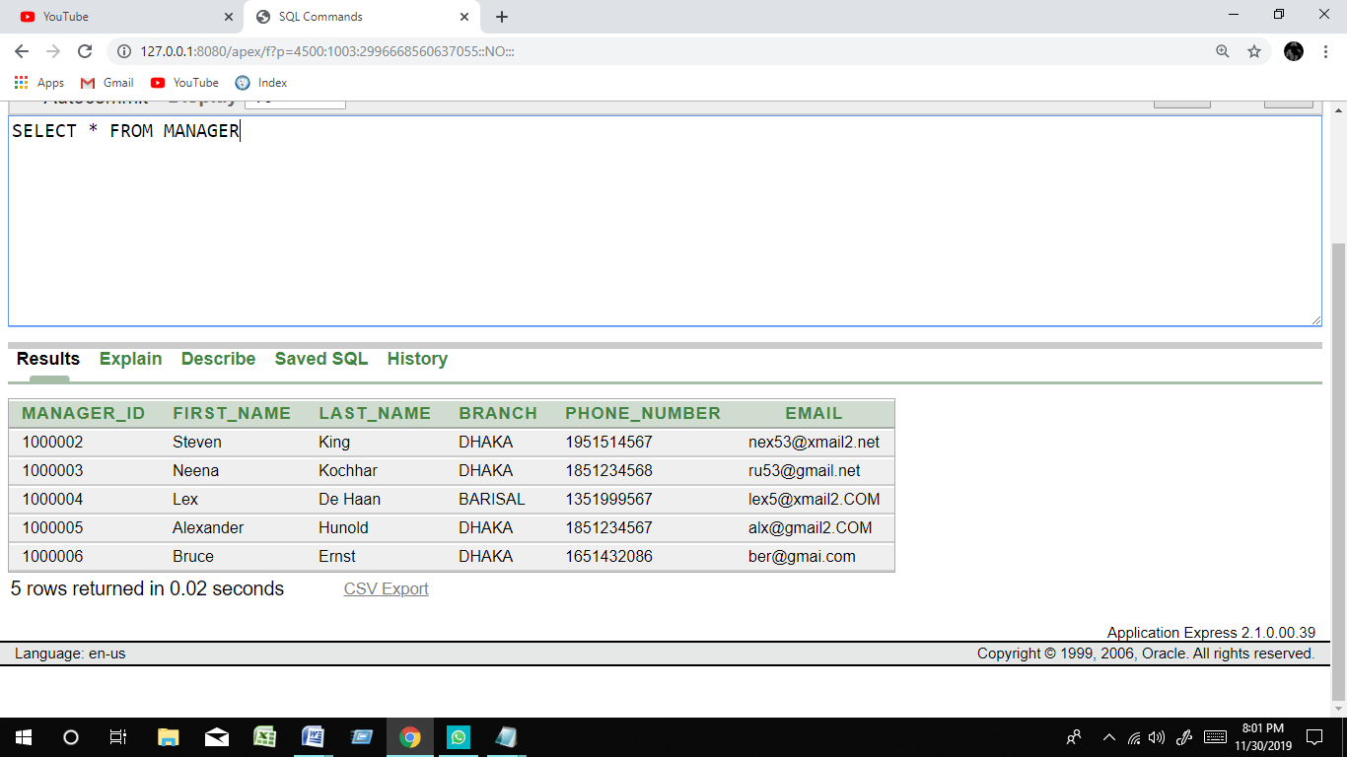

INSERT INTO SUPERVISOR

(SUPERVISOR_ID,FIRST_NAME,LAST_NAME,BRANCH,PHONE_NUMBER,MANAGER_ID) VALUES (SUPERVISOR_ID.NEXTVAL,'David','Austin','DHAKA',01902026859,1000002)

(SUPERVISOR_ID,FIRST_NAME,LAST_NAME,BRANCH,PHONE_NUMBER,MANAGER_ID) VALUES (SUPERVISOR_ID.NEXTVAL,'Valli','Pataballa','BARISAL',01327849015,1000004)

(SUPERVISOR_ID,FIRST_NAME,LAST_NAME,BRANCH,PHONE_NUMBER,MANAGER_ID) VALUES (SUPERVISOR_ID.NEXTVAL,'Diana','Lorentz','DHAKA',01821321456,1000002)

(SUPERVISOR_ID,FIRST_NAME,LAST_NAME,BRANCH,PHONE_NUMBER,MANAGER_ID) VALUES (SUPERVISOR_ID.NEXTVAL,'Daniel','Faviet','BARISAL',01327849015,1000004)

(SUPERVISOR_ID,FIRST_NAME,LAST_NAME,BRANCH,PHONE_NUMBER,MANAGER_ID) VALUES (SUPERVISOR_ID.NEXTVAL,'Nancy','Greenberg','DHAKA',013098790,1000006)

SELECT * FROM SUPERVISOR

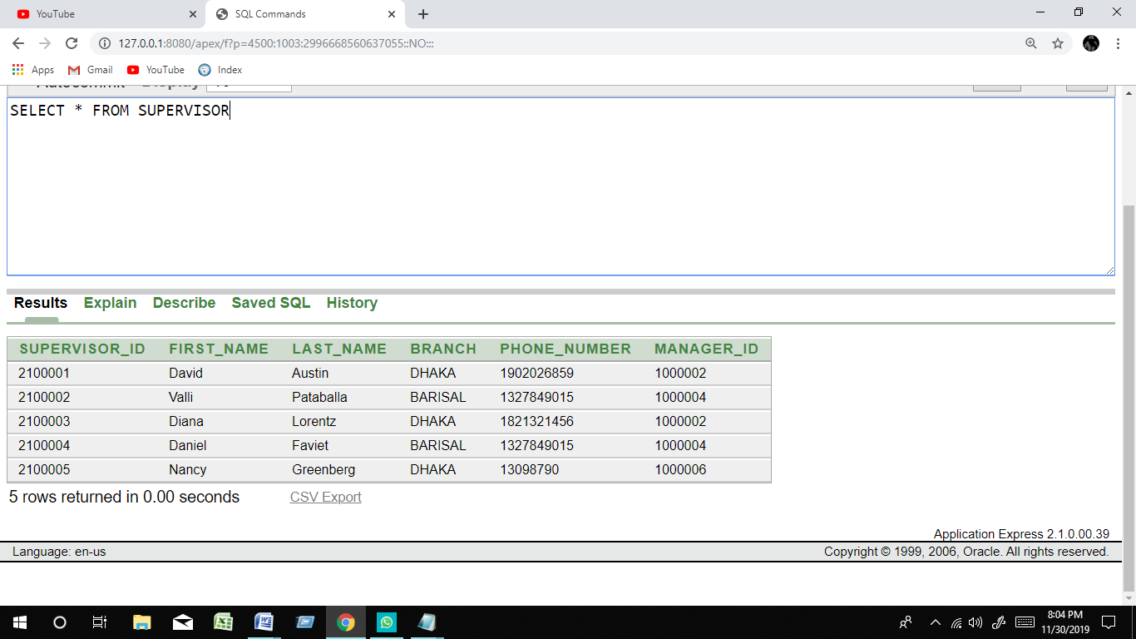

INSERT INTO GUARD_INFO

(GUARD_ID,FIRST_NAME,LAST_NAME,DOB,ADDRESS,PHONE_NUMBER,SUPERVISOR_ID) VALUES (GUARD_ID.NEXTVAL,'Ismael','Sciarra','17-JUN-87','1297 Via Cola di Rie',01745678921,2100001)

(GUARD_ID,FIRST_NAME,LAST_NAME,DOB,ADDRESS,PHONE_NUMBER,SUPERVISOR_ID) VALUES (GUARD_ID.NEXTVAL,'Jose Manuel','Urman','21-SEP-89','2017 Shinjuku-ku',01856745632,2100001)

(GUARD_ID,FIRST_NAME,LAST_NAME,DOB,ADDRESS,PHONE_NUMBER,SUPERVISOR_ID) VALUES (GUARD_ID.NEXTVAL,'Luis','Popp','28-SEP-87','9450 Kamiya-cho',01811213456,2100003)

(GUARD_ID,FIRST_NAME,LAST_NAME,DOB,ADDRESS,PHONE_NUMBER,SUPERVISOR_ID) VALUES (GUARD_ID.NEXTVAL,'Den','Raphaely','25-JUN-97','8204 Arthur St',1986789543,2100004)

(GUARD_ID,FIRST_NAME,LAST_NAME,DOB,ADDRESS,PHONE_NUMBER,SUPERVISOR_ID) VALUES (GUARD_ID.NEXTVAL,'Alexander','Khoo','07-FEB-99','Murtenstrasse 921',01698765786,2100003)

SELECT * FROM GUARD_INFO

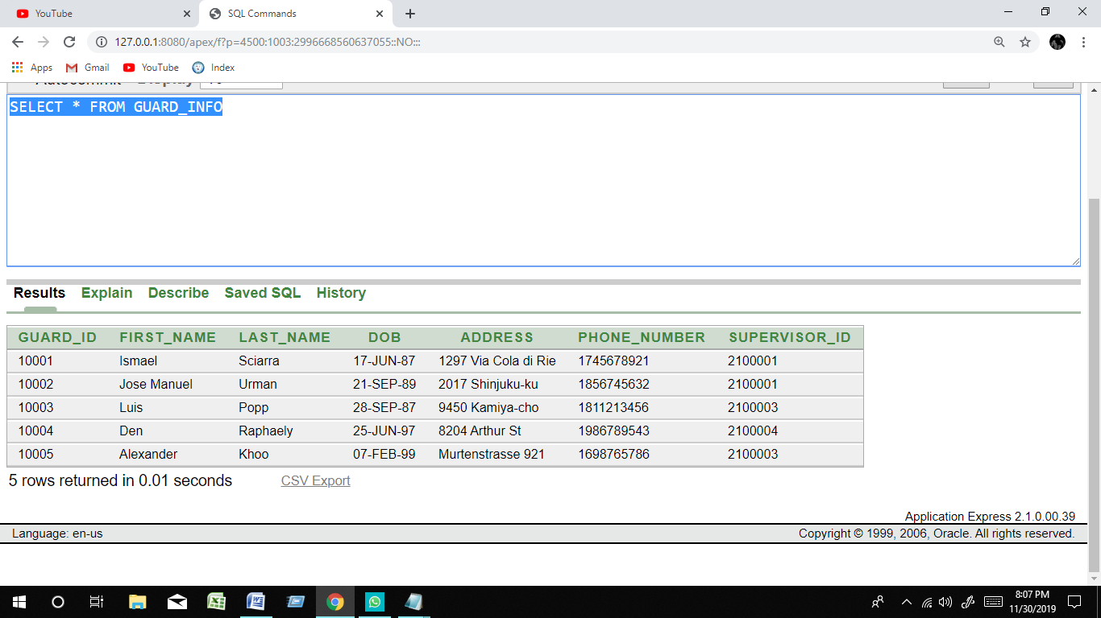

INSERT INTO ACCOUNT

(AN ,SALARY_AMOUNT,COMMISSION,GUARD_ID ) VALUES (10101001, 10000 ,500, 10001)

(AN ,SALARY_AMOUNT,COMMISSION,GUARD_ID ) VALUES (10101002, 12000 ,550, 10002)

(AN ,SALARY_AMOUNT,GUARD_ID ) VALUES (10101003, 13000 , 10003)

(AN ,SALARY_AMOUNT,GUARD_ID ) VALUES (10101004, 14000 , 10004)

(AN ,SALARY_AMOUNT,GUARD_ID ) VALUES (10101005, 15000 , 10005)

SELECT * FROM ACCOUNT

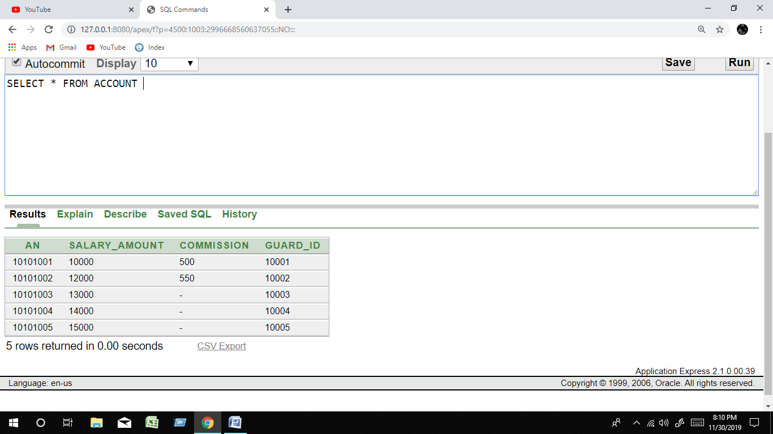

INSERT INTO GUARD

(GUARD_ID ,SUPERVISOR_ID,HIRE_DATE,SERVICE_TYPE) VALUES (10001, 2100001 ,'21-JAN-16','REGULAR')

(GUARD_ID ,SUPERVISOR_ID,HIRE_DATE,SERVICE_TYPE) VALUES (10002, 2100001 ,'07-AUG-16','PART TIMER')

(GUARD_ID ,SUPERVISOR_ID,HIRE_DATE,SERVICE_TYPE) VALUES (10003, 2100003 ,'13-MAR-16','PART TIMER')

(GUARD_ID ,SUPERVISOR_ID,HIRE_DATE,SERVICE_TYPE) VALUES (10004, 2100004 ,'27-JUN-17','REGULAR')

(GUARD_ID ,SUPERVISOR_ID,HIRE_DATE,SERVICE_TYPE) VALUES (10005, 2100003 ,'09-OCT-17','REGULAR')

SELECT * FROM GUARD

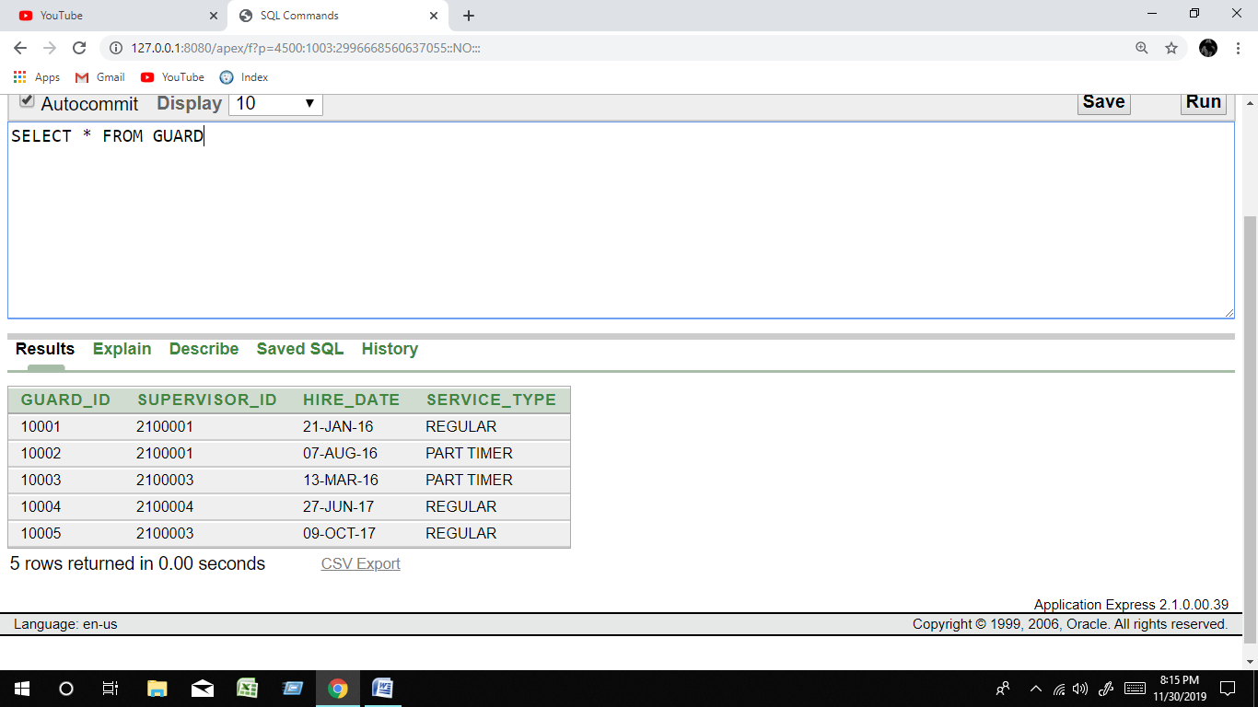

INSERT INTO APPOINTING_INSTITUTION

(AI_CODE_NUMBER ,NAME,EMAIL,ADDRESS,PHONE_NUMBER) VALUES ( 201801 , 'VISE LTD' , 'vise@gmail.com', 'RAMNA', 01946391750)

(AI_CODE_NUMBER ,NAME,EMAIL,ADDRESS,PHONE_NUMBER) VALUES ( 201802 , 'SILINT GP' , 'silint@gmail.com', 'BORGONA', 01309675879)

(AI_CODE_NUMBER ,NAME,EMAIL,ADDRESS,PHONE_NUMBER) VALUES ( 201803 , 'THE SHILD' , 'shild@gmail.com', 'RAMPURA', 01697563142)

(AI_CODE_NUMBER ,NAME,EMAIL,ADDRESS,PHONE_NUMBER) VALUES ( 201804 , 'BLACK RD' , 'black@gmail.com', 'PURAN DHAKA', 01587654756)

(AI_CODE_NUMBER ,NAME,EMAIL,ADDRESS,PHONE_NUMBER) VALUES ( 201805 , 'GROPU 4' , 'g4@gmail.com', 'SANTINAGUR', 01635408653)

SELECT * FROM APPOINTING_INSTITUTION

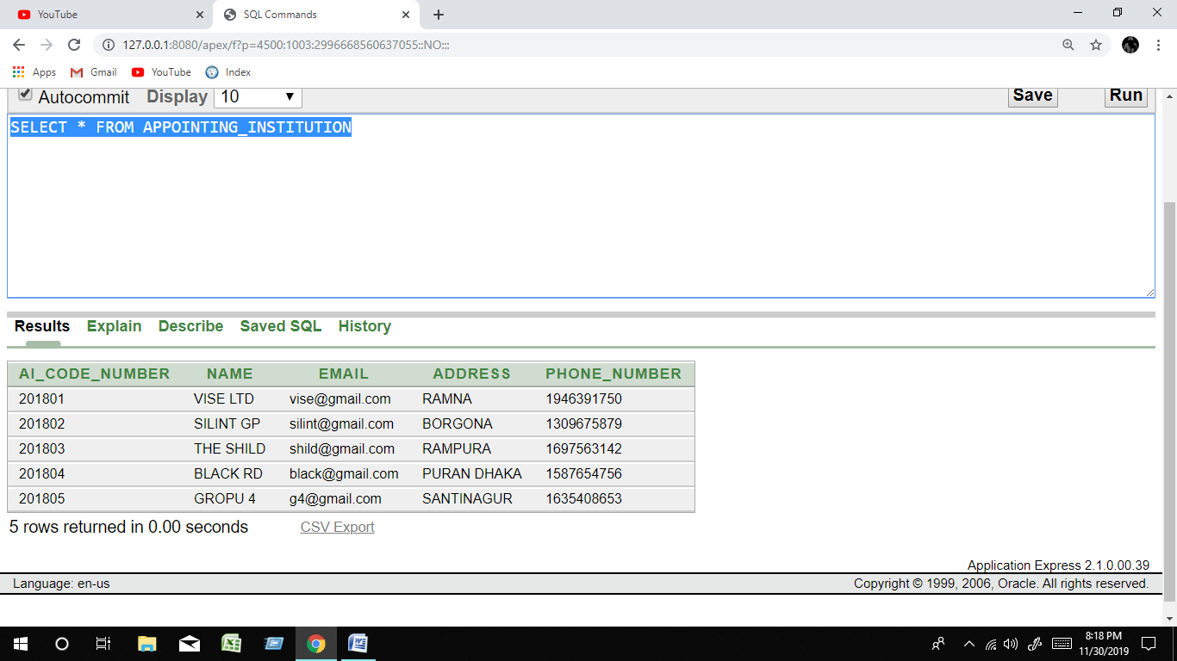

INSERT INTO SECURITY_GUARD_COMPANY

(SGC_CODE_NUMBER,NAME,EMAIL,ADDRESS,PHONE_NUMBER,TYPE,OID) VALUES ( 301601 , 'SG COMPANY' , 'sg@gmail.com', 'MOGBAZAR', 01935408653, 'PRIVATE', 201)

(SGC_CODE_NUMBER,NAME,EMAIL,ADDRESS,PHONE_NUMBER,TYPE,OID) VALUES ( 301602 , 'FGH LTD' , 'fgh@gmail.com', 'MOGBAZAR', 01812436485, 'PRIVATE', 202)

(SGC_CODE_NUMBER,NAME,EMAIL,ADDRESS,PHONE_NUMBER,TYPE,OID) VALUES ( 301603 , 'UBIA LTD' , 'ubia@gmail.com', 'MOGBAZAR', 01638689534, 'PRIVATE', 201)

(SGC_CODE_NUMBER,NAME,EMAIL,ADDRESS,PHONE_NUMBER,TYPE,OID) VALUES ( 301604 , 'TSAE COM' , 'tsae@gmail.com', 'MOGBAZAR', 01958675867, 'PRIVATE', 204)

(SGC_CODE_NUMBER,NAME,EMAIL,ADDRESS,PHONE_NUMBER,TYPE,OID) VALUES ( 301605 , 'BULL DDT' , 'bull@gmail.com', 'MOGBAZAR', 013098098453, 'PRIVATE', 202)

SELECT * FROM SECURITY_GUARD_COMPANY

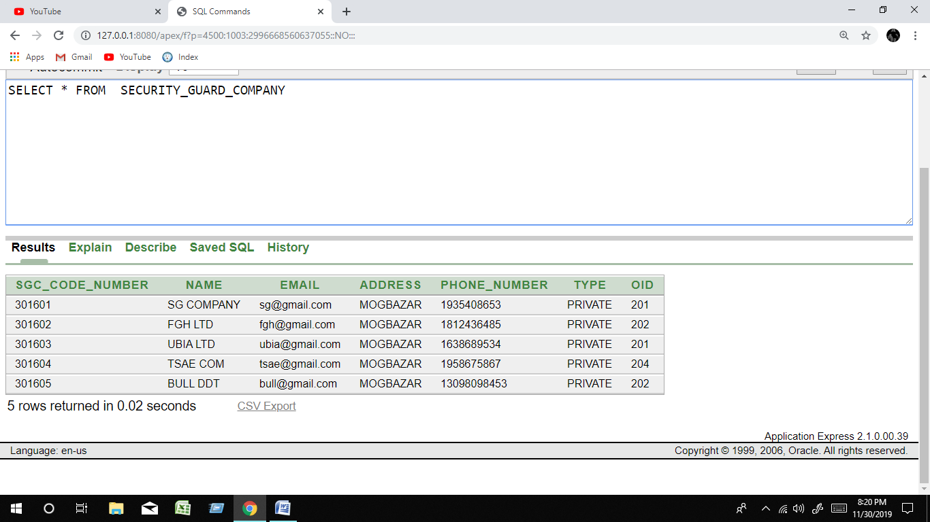

INSERT INTO AS_CODE

(AS_CODE_NUMBER ,AI_CODE_NUMBER ,SGC_CODE_NUMBER) VALUES (311,201801,301601)

(AS_CODE_NUMBER ,AI_CODE_NUMBER ,SGC_CODE_NUMBER) VALUES (312,201802,301601)

(AS_CODE_NUMBER ,AI_CODE_NUMBER ,SGC_CODE_NUMBER) VALUES (313,201803,301603)

(AS_CODE_NUMBER ,AI_CODE_NUMBER ,SGC_CODE_NUMBER) VALUES (314,201804,301605)

(AS_CODE_NUMBER ,AI_CODE_NUMBER ,SGC_CODE_NUMBER) VALUES (315,201805,301603)

SELECT * FROM AS_CODE

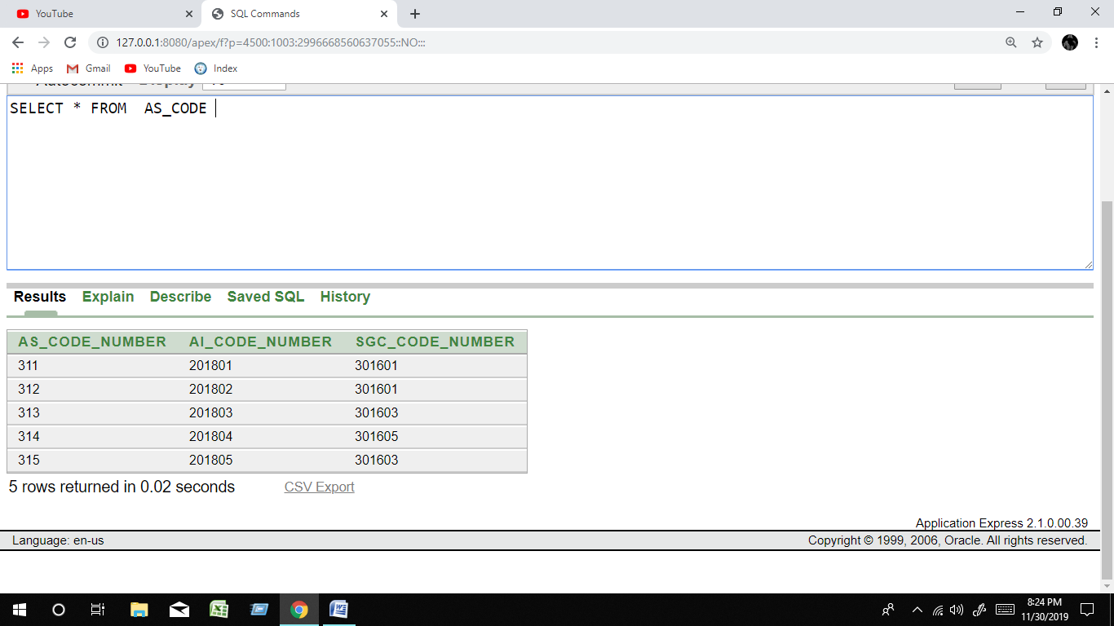

INSERT INTO GUARD_INSTITUTION

(GUARD_ID ,FIRST_NAME,LAST_NAME,DOB,ADDRESS ,PHONE_NUMBER,AI_CODE_NUMBER) VALUES (10001,'Ismael','Sciarra','17-JUN-87','1297 Via Cola di Rie',01745678921,201801)

(GUARD_ID ,FIRST_NAME,LAST_NAME,DOB,ADDRESS ,PHONE_NUMBER,AI_CODE_NUMBER) VALUES (10002,'Jose Manuel','Urman','21-SEP-89','2017 Shinjuku-ku',01856745632,201802)

(GUARD_ID ,FIRST_NAME,LAST_NAME,DOB,ADDRESS ,PHONE_NUMBER,AI_CODE_NUMBER) VALUES (10003,'Luis','Popp','28-SEP-87','9450 Kamiya-cho',01811213456,201802)

(GUARD_ID ,FIRST_NAME,LAST_NAME,DOB,ADDRESS ,PHONE_NUMBER,AI_CODE_NUMBER) VALUES (10004,'Den','Raphaely','25-JUN-97','8204 Arthur St',1986789543,201803)

(GUARD_ID ,FIRST_NAME,LAST_NAME,DOB,ADDRESS ,PHONE_NUMBER,AI_CODE_NUMBER) VALUES (10005,'Alexander','Khoo','07-FEB-99','Murtenstrasse 921',01698765786,201803)

SELECT * FROM GUARD_INSTITUTION

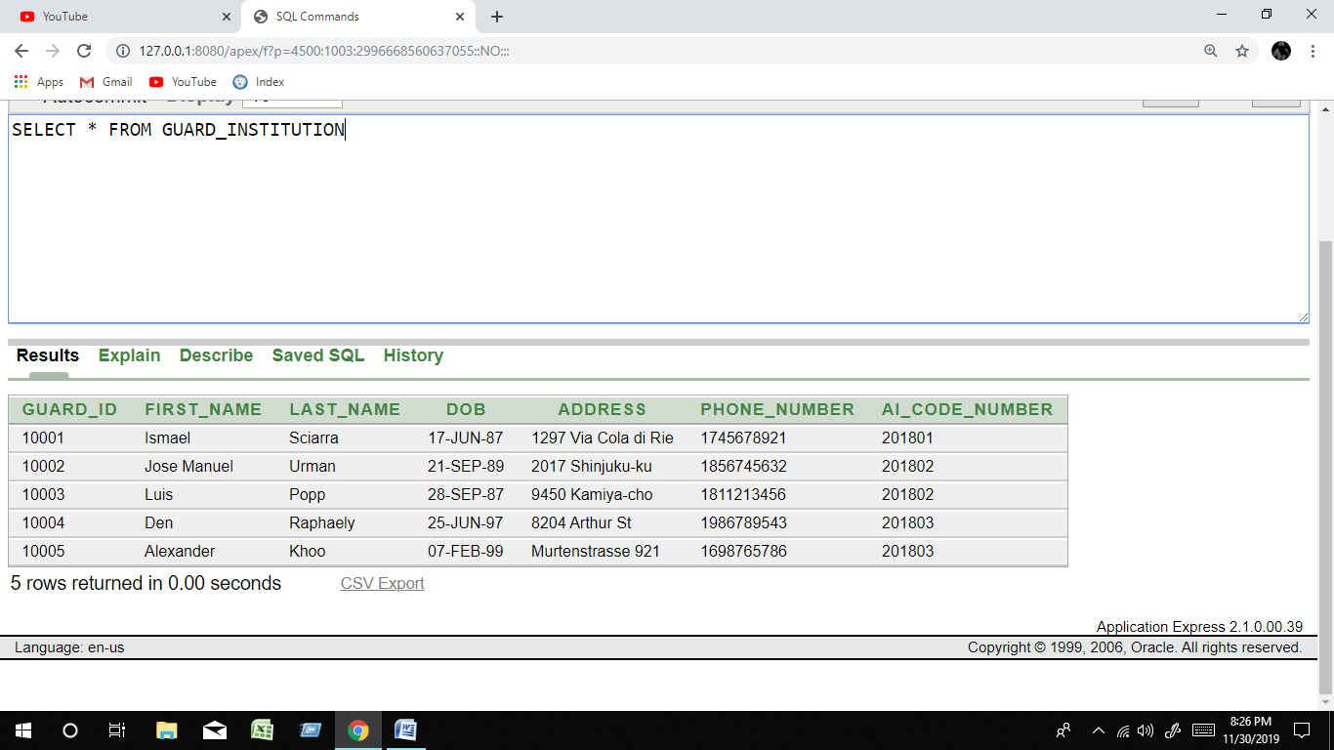

INSERT INTO OWNER

(OID ,FIRST_NAME,LAST_NAME,BRANCH,PHONE_NUMBER,EMAIL,SCG_CODE_NUMBER) VALUES (201,'Trenna','Rajs','DHAKA',01913091988,'trenna@gmail.com',301601)

(OID ,FIRST_NAME,LAST_NAME,BRANCH,PHONE_NUMBER,EMAIL,SCG_CODE_NUMBER) VALUES (202,'Curtis','Davies','DHAKA',018132412356,'cuiv@gmail.com',301602)

(OID ,FIRST_NAME,LAST_NAME,BRANCH,PHONE_NUMBER,EMAIL,SCG_CODE_NUMBER) VALUES (203,'Randall','Matos','KHULNA',01512121456,'randi@gmail.com',301603)

(OID ,FIRST_NAME,LAST_NAME,BRANCH,PHONE_NUMBER,EMAIL,SCG_CODE_NUMBER) VALUES (204,'Jfla','DABIT','DHAKA',01367512310,'jfla@gmail.com',301604)

(OID ,FIRST_NAME,LAST_NAME,BRANCH,PHONE_NUMBER,EMAIL,SCG_CODE_NUMBER) VALUES (205,'Tamim','Khan','DHAKA',01912309865,'tamim@gmail.com',301605)

SELECT * FROM OWNER

